Supporting the transition from student to midwife
speaker biographies

Sara Cottenden, Registered Midwife
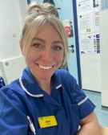
Sara is a new band 6 midwife working at a busy trust in the South-East of England. As a student Sara had a passion for low-risk midwifery care which she is able to bring into her role as a community midwife. Sara has gained a large social media following by documenting her journey as a student, newly qualified midwife, and Band 6 midwife through her Instagram @thelifeofamidwife_. Her posts about the ups and downs of the life of a student and midwife have captivated a large audience and has been an inspiration to other student midwives on the same journey.

Fiona Gibb, Head of Education, Royal College of Midwives
Fiona leads the education team who are responsible for the design and implementation of education at the Royal College of Midwives. She is the RCM Lead Midwife for Education (LME) and works with partners to influence and guide national strategy including the NMC, education commissioners and HEI's about the importance and distinctness of midwifery practice, education, and regulation. In addition, she is a member of the LME-UK network, the RCM Student Midwife Forum and other key stakeholder groups across the four UK countries. Prior to joining the RCM in 2021, Fiona was LME and Senior Lecturer at Robert Gordon University, where she continues to be an associate lecturer. . Her research interests have included the use of technology in education and the involvement of women and families in undergraduate teaching and learning. Before moving into an education career pathway, Fiona was a Senior Charge Midwife in NHS Grampian specialising in labour and birth. She is passionate about supporting students and midwives on career pathway journeys in practice, education, research, management, and leadership.

Jennifer Kwarteng, 3rd year Student Midwife, De Montfort University
I am studying at De Montfort University. I am 21, in my final year and am planning to go back to practise where I grew up which is a town called Colchester, Essex. It's been a ride these last three years but I'm very excited and nervous to finally finish, I'm sure we are all in the same boat!

The transition from being a student to a NQM is absolutely daunting and I am incredibly nervous to not only potentially start at a new trust but to be a lot more independent! I am however looking forward to my new title, which I’m incredibly proud of, and to be able to continue to make a difference to birthing people and their families. I hope that the transition to being a NQM will be a smooth one through good support with my preceptorship. The last three years have been a rollercoaster but I'm very excited and nervous to finally finish, I'm sure we are all in the same boat!

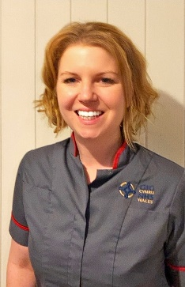
Cerian Llewellyn, Risk and Governance Midwife, Hywel Dda University Health Board
Cerian has been a proud and passionate midwife for 15 years, and has worked in a variety of clinical settings as well as in the education environment. Cerian studied at Swansea University and her career began as a clinical midwife working in west Wales, over time her career saw her moving into education where she became a lecturer. Cerian later secured fellowship to the higher education academy and later returned to clinical practice to pursue her passion for education in clinical practice.. Cerian currently works for Hywel Dda University Health Board as the Risk and Governance Lead Midwife but remains focused on the value of education to collectively learn and grow and has spent the last 12 months working for Health Education Improvement Wales as the programme manager for the implementation of the Future Midwife standards across Wales.

Cerian has recently been awarded the honour of a Florence Nightingale Leadership Scholarship which she intends to dedicate to developing as a compassionate leader to promote a midwifery service which is safe, sustainable and that truly empowers midwives to fulfil their role.

We all know that it is a challenging time for maternity services at the moment and change will not come overnight, however we must remain passionate that midwifery will continue to flourish and women and birthing people will continue to receive the high quality, individualised care they truly deserve – we must remember that we are the change that we seek and our career pathways are as unique as we are!!

Tina South, Lead Midwife for Education, Liverpool John Moores University
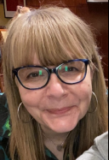
Tina is a proud Registered Midwife, Midwifery Researcher, Programme Manager and Lead Midwife for Education at Liverpool John Moores University. Tina is the recipient of three international awards for her PhD research - The lived experiences of childbearing midwives: a hermeneutic phenomenological study.
Tina is passionate about providing kind and compassionate care for women and their families within maternity services in the NHS, and also that this type of care is extended to midwifery colleagues and future midwives. Tina enjoys being part of and encouraging others to join and interact with the tweeting midwifery tribe and tweets regularly as @tinasouth3 and is also one quarter of @MidwivesinMind

