Supporting and nurturing students webinar
speaker biographies

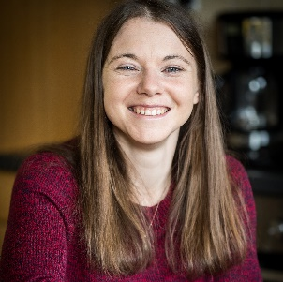
Ellie Durrant
Ellie trained as a midwife in Leicester. She's been a staff midwife in the UK and also in New Zealand. After writing two books, she is now working as a midwife in the same hospital in which she was born. Ellie has loved reading since she was a little kid in a summer dress sitting with her back pushed up against a warm brick house exterior hiding in a honeysuckle bush so she could finish her book. Ellie’s professional life has involved speaking at events such as The RCM Conference and she has shared a stage with midwives Sheena Byrom and Virginia Howes, and obstetrician Michel Odent. Her current writing project is Becoming a Midwife, commissioned by Macmillan. Ellie's work includes: Becoming a Student Midwife - an application guide. New Walk - a midwifery novel. A highly-rated career support service, offering coaching for personal statement and interview coaching for aspiring, student and qualified midwives.

The Secret Community For Midwives In The Making, a big Facebook group.
Facebook: midwifediaries & Secret Community for Midwives in the Making
Instagram: midwifediariesellie
Website: midwifediaries.com
Leah Hazard
Leah qualified as a midwife in 2013 and has worked in numerous different clinical areas since then. She is also the author of The Father’s Home Birth Handbook, Hard Pushed: A Midwife’s Story, and the forthcoming book Womb: The Inside Story of Where We All Began (due out in 2023). She is the host of the podcast What The Midwife Said and an active advocate for midwives and students across the UK.
Twitter - hazard_leah
Instagram - leahhazard

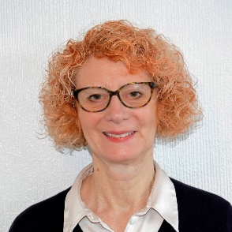
Dr Diane Menage
Diane is a Senior Lecturer in Midwifery at De Montfort University. She is also a mother, grandmother, writer and feminist with a life-long interest in women’s health and well-being. Throughout her career her focus has always been on providing safe and effective care through relationships. She has worked clinically in hospital settings, community midwifery and independent practice. She completed her PhD thesis on Women’s Lived Experience of Compassionate Midwifery at Coventry University (UK) in 2018 and she has published widely.
Twitter: @Dianethemidwife

Melissa Newman
Melissa qualified as a midwife almost 5 years ago and has since completed a Masters in Genomic Medicine, won an alumni award, presented her work at the RCM conference and published numerous journal articles. She is currently in the third year of her Professional Doctorate, in which her research combines midwifery and paramedicine. Melissa is passionate about encouraging and empowering aspiring, student and qualified midwives to fulfil their career aspirations and use their voices to invoke positive change to benefit the families we care for as well as ourselves.
Instagram: @_midwifelife_
Twitter: @Midwife_Melissa

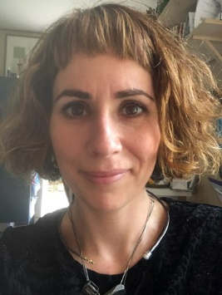
Dr Jan Smith
Jan is a HCPC and BPS registered Chartered Psychologist and is the director of Healthy You Ltd, an independent psychology practice. For over 10 years, she has supported clients who have experienced birth-related trauma, and also healthcare staff who are suffering from vicarious trauma, burnout, moral injury or stress. Jan is the Clinical Lead for the national birth trauma campaign, Make Birth Better, and leads the Parliamentary Working Group for Birth Trauma.

Jan is part of the NHS Leadership Academy and provides leadership coaching within the healthcare industry. She is Head of Clinical and Wellbeing Services at Kura Human Factors. Jan holds a research post at Sheffield Hallam University.

Jan has written and published about the impact of moral injury and vicarious trauma on staff, as well as a preventing and managing birth trauma in maternity. She has written, ‘Nurturing Maternity Staff: How to Tackle Trauma, Stress, and Burnout to

Create a Positive Working Culture in the NHS’, and ‘Help for the Helpers: Managing the Effects of Psychological Trauma in Health & Social Care Staff’. Two books due for publication in 2022 are ‘Using Acceptance and Commitment Therapy Following Birth Trauma: A Workbook’ and ‘Acceptance and Commitment Based Approaches for Perinatal Anxiety’.
@healthyyoultd

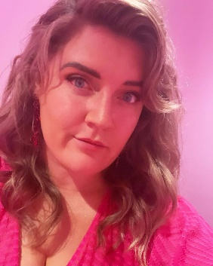
Hana Young
I qualified as a midwife in 2020 from the University of Surrey, my cohort were the first to pay student loans and stepped up into the NHS workforce early to support them during COVID. I qualified into the second wave, moving to a much bigger trust and managed the seismic change into being a NQM during a pretty horrible time to be a midwife.

I have been writing my blog mama unexpected for the past six years and have enjoyed documenting my life as a single mother of a child with metabolic disorder and her rowdy brother. Nothing makes me happier than showing others they absolutely can train to be a midwife despite their circumstances.

I’m now a very happy community midwife with a passion for providing continuity to my caseload and ensuring they enjoy their pregnancies feeling safe, listened to and cared for. I am also very passionate about nurturing and empowering our student midwives to become confident and happy practitioners. The future of midwifery depends on our students, we need to make big changes nationally to support them.

I don’t have big plans to change the whole midwifery world, my goal is to make those big changes for those in my care and under my supervision/mentorship. That said, my matron keeps laughing at me when I say I’m not going to do my masters.
@mama_unexpected

