“Live Webinar Panel: Why midwives and maternity support workers deserve a pay rise!”
24 March 2021, 18:00 - 19:00 live

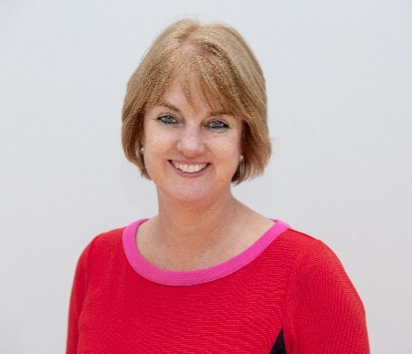
Gill Walton is the Royal College of Midwives’ Chief Executive. Gill is an experienced and acknowledged midwifery leader and manager. Before joining the RCM, she was the Director of Midwifery and Maternity Services at Portsmouth Hospitals and held similar posts at the Royal Berkshire Hospitals, Barking and Havering and Redbridge, and the John Radcliffe in Oxford. Gill has led many NHS transformation programmes for maternity services and has been involved in national strategic policy developments including work with the Nursing and Midwifery Council, Department of Health and other regional strategic bodies. Gill is an advocate for improvements in maternity care and involving the wider maternity team.

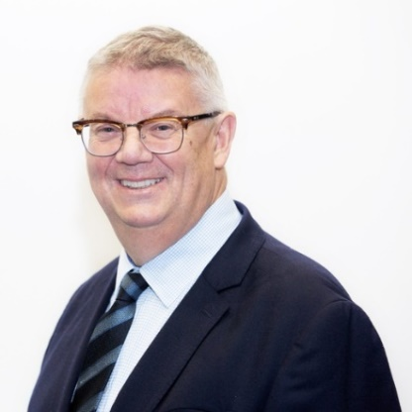
Jon Skewes is the RCM Executive Director for External Relations. His role encompasses being the RCM’s senior negotiator as well as being responsible for engaging on strategic employment and workforce matters in the NHS. Jon is responsible for policy, global ,safety and quality teams in the RCM and oversight generally of its work to influence and collaborate with others. He represents the RCM on the TUC General Council, the NHS Staff Council, the Social Partnership Forum and the Public Services Forum. He is Vice Chair of Unions 21.
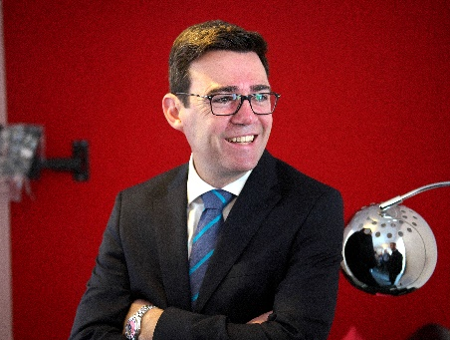
Andy Burnham was elected as Mayor of Greater Manchester in May 2017.
Responsible for shaping the future of Greater Manchester, Andy’s priorities include ending rough sleeping, transforming Greater Manchester into one of the greenest city regions in Europe, and making Greater Manchester a great place to live, get on, and grow old.
The Mayor works closely with the Greater Manchester Health and Social Care Partnership to improve the health and wellbeing of the 2.8 million people living in Greater Manchester.

The Mayor has been a longstanding advocate of health and social care integration, and is passionate about improving access to mental health services.
Before being elected Mayor of Greater Manchester, Andy was MP for Leigh from 2001. In government, Andy held Ministerial positions at the Home Office, Department of Health and the Treasury. In 2008 he became Secretary of State for Culture, Media and Sport, before returning to Health as Secretary of State in 2009. In February 2010, Professor Sir Michael Marmot presented Andy with his final report – ‘Fair Society Healthy Lives’.
In opposition, Andy served as Shadow Education Secretary, Shadow Health Secretary and Shadow Home Secretary.
Andy lives in Leigh, Greater Manchester, with his wife and three children. He is a keen supporter of Everton FC.

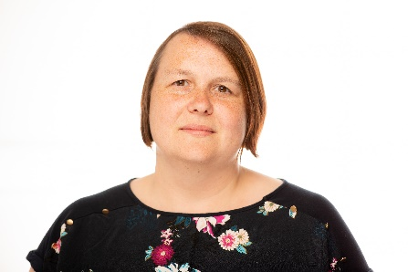
Keelie Barrett is a maternity support worker from East Lancashire Hospitals. In addition to this role, she is also an RCM workplace representative and MSW advocate. Keelie is passionate about promoting Health and Safety and wellbeing in the workplace and in 2019 became the first MSW to become elected to join the RCM board.

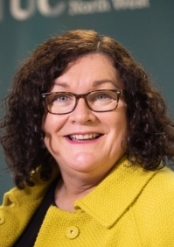
Lynn Collins, TUC North West Regional Secretary
Lynn was appointed Regional Secretary of the TUC in the North West in 2013, the first woman to hold that position. Prior to her appointment at the TUC Lynn worked for a number of trades unions in senior positions, and served on a number of equality bodies, including the Women’s National Commission.
As Regional Secretary Lynn coordinates and represents around 800,000 workers in 48 different trades unions in the region. She serves as a member of the North West Leaders Board and pursues he personal determination to tackle poverty and inequality by serving on the Greater Manchester Poverty Commission and the Liverpool City Region Poverty and Life Chances Action Group. In 2017 Lynn was appointed by Steve Rotheram, the Metro Mayor of Liverpool City Region, as Mayoral Advisor on Equalities, and as Chair of his Fairness and Social Justice Advisory Board.

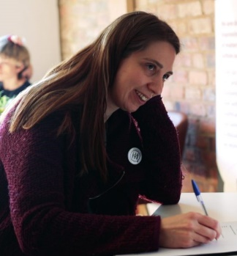
Cathy Brewster, Greater Manchester Maternity Voices Partnership
Cathy has been a service user representative on Stockport Maternity Voices Partnership (MVP) since the birth of her youngest child seven years ago has co-chaired for the last three. She is a founder member of National Maternity Voices and represents service users nationally on the NHS England Maternity Transformation Programme workstream 7: Harnessing Digital Technology. Cathy has undertaken co-creation and mentor training with NHS England to qualify as one of the first MVP mentors in the country. She has presented at events both regionally and nationally on coproduction and MVPs such as the Royal College of Midwives Annual Conference, Better Births 4 Years On and NHS EXPO

Maryanne Naylor, Midwife and RCM Steward Bradford Royal Infirmary
Maryanne qualified as a registered nurse at the university of Bradford in 2000 and worked in vascular surgery in Bradford.
She converted to midwifery at the University of Bradford and started working on labour ward as a qualified midwife in 2007. Maryanne has rotated around the unit spending the majority of her career on labour ward. Last yearshe started a specialist role as the safer maternity care midwife. Her role primarily involves imbedding the recommendations and principles from the saving babies lives care bundle. Maryanne has been an RCM rep for 7 years.

