Name
Current job title and band
NHS Board where employed
RCM Membership number
Name and contact email for line manager

Additional study or continuing professional development related to perinatal mental health since qualification.

What motivates you to apply to the forum?

What would you bring to the RCM Scotland’s PMH Forum? What qualities, particular interests, expertise (in 500 words or less)

What would you hope to gain from your involvement with PMH Forum? (in 250 words or less)

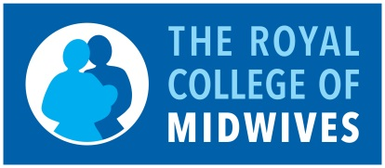
The RCM Scotland Perinatal Mental Health Forum
Application Form

